1. Write a Java program to create a new array list, add some colors (string) and print out the collection.

package Collections;

import java.io.\*;

import java.util.\*;

public class AddElements {

public static void main(String args[]) {

Collection<String> list = new LinkedList<String>();

list.add("Green");

list.add("Blue");

list.add("Orange");

System.out.println("The list is: " + list);

list.add("Red");

list.add("Black");

System.out.println("The new List is: " + list);

}

}

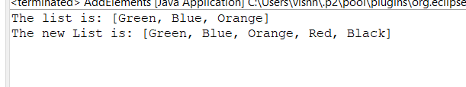

1. Write a Java program to retrieve an element (at a specified index) from a given array list.

package Collections;

import java.util.ArrayList;

import java.util.List;

public class Retrieve {

public static void main(String args[]) {

List<Integer> list = new ArrayList<>();

list.add(100);

list.add(500);

list.add(1000);

System.out.println(list);

System.out.println("The element at index two is " + list.get(2));

}

}

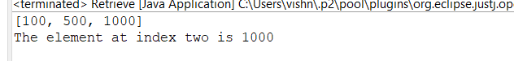

1. Write a Java program to iterate through all elements in an array list.

package Collections;

import java.util.\*;

public class Iterate {

public static void main(String[] args) {

List<Integer> numbers = Arrays.asList(1, 2, 3, 4, 5, 6, 7, 8);

for (int i = 0; i < numbers.size(); i++)

System.out.print(numbers.get(i) + " ");

}

}

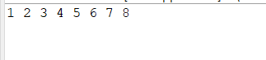

1. Write a Java program to remove the third element from an array list.

package Collections;

import java.io.\*;

import java.util.\*;

public class RemovingElement {

public static void main(String args[]) {

Collection<String> list = new LinkedList<String>();

list.add("Green");

list.add("Blue");

list.add("Orange");

list.add("Black");

list.add("Pink");

System.out.println("The list is: " + list);

list.remove("Black");

System.out.println("The new list is: " + list);

}

}

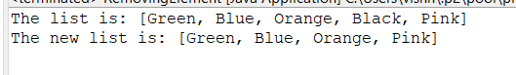

1. Write a Java program to search an element in an array list.

package Collections;

import java.io.\*;

import java.util.\*;

public class Search {

public static void main(String args[]) {

Collection<String> list = new LinkedList<String>();

list.add("Green");

list.add("Blue");

list.add("Orange");

System.out.println("The list is: " + list);

if (list.contains("Blue")) {

System.out.println("Got the colour");

} else {

System.out.println("Blue is not present in the list");

}

}

}

